**QUESTION BANK**

**Stage 1:** Questionnaire for parents   
**Stage 2**: Application based test for Identification of Learning Disability and Treatment of the same.

**DYSLEXIA**

**Stage1:   
[**Very often, often, sometimes, rarely, never]

1. Does your child reverse the letters d and b (bog rather than dog) while speaking?
2. Does your child write letters and numbers the wrong way round while writing? E.g., interchanging the similar looking letters with one another like ‘p’, ‘b’, ‘d’
3. Does your child find it hard to remember a word they just read?
4. Does your child find it difficult to read aloud simple words that may be common in their age? E.g., football, pizza, story etc.
5. While reading, does your child miss out on some words or sentences?
6. Is your child able to clearly express or verbalize their ideas in words coherently?
7. Does your child have difficulty learning or recalling letters in the alphabets?
8. Is your child able to construct sentences properly while reading?

**Stage 2:**Speech to text test**: small sentences/paragraphs will be given to students to read. What the student speaks will be compared to the text displayed on screen.**

**Over here you can record the number of errors made in pronunciation, how much time they took to read simple words that are supposed to be easy to read for their age, and if they interchanged the letters while pronouncing a word e.g., if the word is ‘dog’ but they read it out as ‘god’**

**DYSCALCULIA:  
Stage 1:   
[**Very often, often, sometimes, rarely, never]

1. Is the child able to solve the numeracy questions i.e  
   - Count or make connection with words eg. four is 4  
   - Recognize and write numbers  
   - Tell the sequence of numbers
2. Is the child able to do the calculations i.e.,  
   - Being able to work out with addition, subtraction, multiplication or division  
   - Recognize mathematical signs  
   - Decide what math operation to use
3. Is the child able to grasp the Math Language i.e.,  
   Understand mathematical concepts such as greater than, less than
4. Is the child able to do identify visual - spatial objects i.e.,  
   Tell left to right
5. Is your child able to classify 3D objects by seeing them from different angles? (this question is vague please try to reword it and explain it better)
6. Is the child able to perform sorting i.e.,  
   Able to sort numbers and items having common characteristics (give an example for the same)
7. Is the child able to recall the numbers in a numerical seqeunce? Give exmaples
8. Does numbers and math seem like a foreign language to your child? (sounds a little vague; will have to reword it)

**Stage2:**MCQ/ Animation based questions**:**

**For example:**

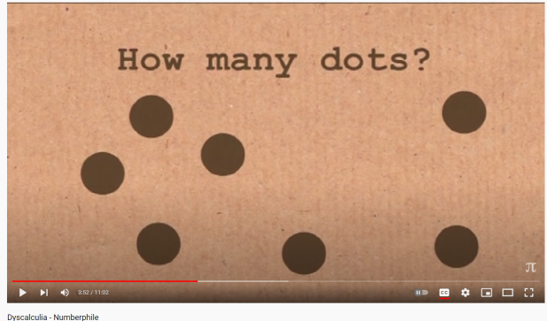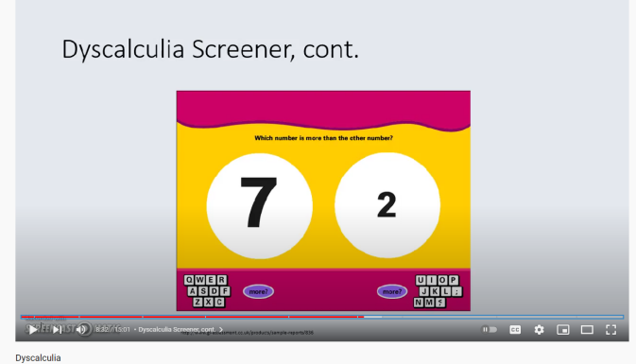

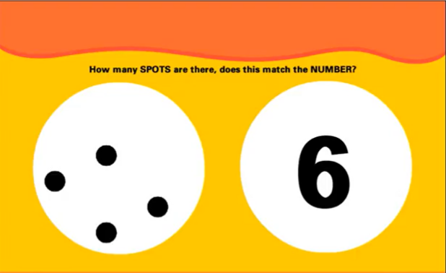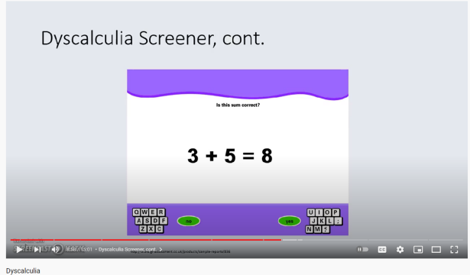

**ADHD:**

**Stage1:   
[**Very often, often, sometimes, rarely, never]

1. How often does your child find the majority of the tasks (work/school assignments, etc.) boring or repetitive/difficult to complete?
2. Does your child have difficulty concentrating or paying attention on people when they are speaking to him/her?
3. Does your child find it hard to focus in the presence of external stimuli? (e.g. over ehre external stimulis is loud noises, other children playing of talking, other people have conversations etc.)
4. Does your child struggle to follow instructions or pay attention to details? (you can remove the highlighted part)
5. Does your child have difficulty sustaining attention in tasks or play activities?
6. Does your child avoid, dislike, or reluctantly engage in tasks requiring sustained mental effort?
7. Does your child find it difficult to be seated at one particular place for prolong period of time?
8. Does your child fidgets with hands or feet or squirms in their seat? You can also ask if the parents have noticed if the child finds it difficult to be seated in one place for too long.
9. Does your child run or climb excessively in situations in which it is inappropriate? You can also ask if the child tends to maybe wander off or get distracted and walk away unknowingly when they are in a public place. E.g. when a parent and child go out like to a mall or park the child will always walk near the mom or hold their moms hand but sometimes children with adhd may get distracted by something and wander off
10. Does your child blurt out answers before questions have been completed?
11. Does your child interrupt or intrude others?

**Stage 2:** Show a small story/picture on screen and ask simple questions based on it after some time. (story/picture will be closed)

After the story you can also ask them some specific questions about the story. Your aim for this task can be how much did they recall of the story, whether the answers the child gives are relevant and coherent with the story because sometimes children with adhd may also add their own version or own imagination of the story when it was not even part of the actual story

**Dysgraphia**

**Stage 1**:

1. Does your child hold pencils, pens, or markers awkwardly? If possible try giving an example because ‘awkwardly’ is very subjective
2. Is your child’s handwriting legible? (this is a very general question, all the parents will respond with yes to this) Change it to something like ‘does the child’s overall handwriting appear uneven or distorted?’
3. Does your child miss out on letters while writing?
4. Does writing or drawing hurt or make your child’s hand tired?
5. Does your child have difficulty in picking up small objects? (this is a symptom of dyspraxia and not dysgraphia) change to – Does your child face difficulty distinguishing between capital and lowercase letter forms while writing?
6. Does your child feel the need to make excuses to try to get out of writing assignments at school or at home?
7. Does your child make spelling errors in common words when writing?
8. Does your child get restless when writing; moving around and getting distracted easily?

**Stage 2:**

An activity sheet (hard copy) will be given to the child on which

1. he has to write down(copy) the same paragraph printed on it.
2. Trace down alphabets (what does this mean?)
3. Answer some simple questions (questions will be played as audio. Child has to hear it and write down answer)

Another goal can also be to try and ask the child to write ½ or 1 full page about anything they want. This is called spontaneous writing and it will show what the child’s natural and on the spot handwriting would look like. When a child copies from something they will **try** to follow grammatical rules and punctuations. But if you ask a child to write freely you will understand how they reproduce their thoughts on paper and whether or not they are following grammatical rules like

First letter of proper nouns in are in capitals. It will be America not **america**

Common nouns will be lowercase. pizza and not **Pizza**

Do this test on a blank paper to see if they are trying to write in a straight line or if their sentences are slanting downward are they move from left to right while writing

Is their handwriting consistent or does the handwriting style change as they write more and more down the page